OASIS:

An Online Assessment System for Individual Scores

Instructor Manual

**____________________________________________________**

FIRST EDITION

<Insert the logo for OASIS here>

**OASIS: Instructor Manual**

This manual should not be reproduced or distributed in any form or by any means, or stored in a database or retrieval system without the prior written consent of Professor CK Woo at Department of Asian and Policy Studies (APS) at The Education University of Hong Kong (EdUHK). This should not be broadcasted for any on-line and distance learning and should not be included in any network or electronic storage.

<insert the web link of OASIS here>

Table of Contents

**SECTION 1: Description of the Online Assessment System**

Overview**……………………………………………………………………………………...3**

**SECTION 2: How to Download and Install the System…………………………………..4**

**SECTION 3: Key Components of the System………………………………………….…..5**

(1) Statement of commitment (SC)

(2) Statement of output (SO)

(3) Individual contribution

(4) Individual scoring

**SECTION 4: A Worked Example of the Scoring Rule…………………………………….6**

Announcement of Member-specific Contributions

Individual Contribution Calculation

Individual Score Calculation

Adjusted Contribution of Individual Team Member

Relative Contribution of Individual Team Member to Overall Project Score

Individual Score for Team Members

**SECTION 5: Timeline and Steps of Implementation………………………………………8**

**SECTION 6: Frequently Asked Questions………………………………………………….10**

**SECTION 1: Description of OASIS**

**Overview**

OASIS is an online process for teachers to timely assess individual contributions to students’ team projects in courses of any discipline at higher education institutions. It provides an innovative solution to the common problem of free riding faced by teachers worldwide. It is less vulnerable to a team member’s strategic behavior that can bias individual scores comparing to any other popular online assessment systems. The process is fully documented in a 2017 working paper, “A new process to fairly score individual contributions to a team project” by Woo, C.K., A. Shiu, C. Christine and D. Bryant.

OASIS is more than just an online scoring process. It proposes a scoring rule which follows the theory of incentive design and performance-based regulation that guard against strategic behaviors of gaming and collusion within a project team. It facilitates learning and teaching by offering a fair individual scoring process, discouraging free riding in a team project setting and allaying teachers’ cost concerns of implementation. It provides students with performance-based incentives and allows them to learn the art of effective negotiation supported by sound reasoning and convincing evidence, equipping them with valuable learning experience that is an important soft skill to enter the workplace.

Based on estimates of individual contributions, OASIS generates individual project scores for team projects. The input requirements from students and teachers are simple. At the commencement of the academic semester, each student team in a class uploads a Statement of Commitment (SC), which is a useful reminder of individual responsibilities throughout the team project duration. Following the completion of the team project, the team completes a Statement of Output (SO) that documents member-specific contributions, an outcome resulting from effective negotiation among team members in a semester-end meeting of project reflections. Given the member-specific contributions, the system will calculate individual contributions based on a median estimation that uses peer assessment data in the SO. Given a teacher’s overall score for a team project, the system automatically produces individual scores for each member in the team project.

**SECTION 2: How to Download and Install the System**

The OASIS website is under construction. One important component of the website is the fully automated Excel spreadsheet.

The following shows an excerpt from a sample of the spreadsheet for a 5 person team:

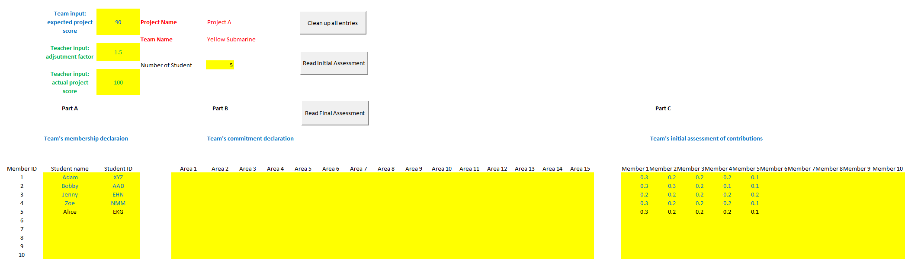

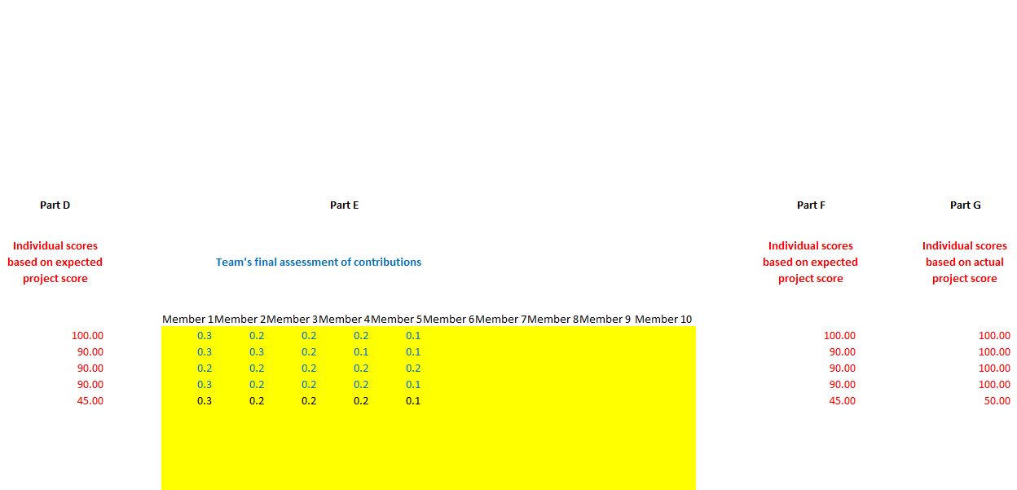

**SECTION 3: Key Components of the System**

There are several key components of the online assessment system:

**(1) Statement of commitment (SC)**:

Each member of a team project must:

* Sign a SC that reflects the course’s expectation of fair contribution and high cooperation; and
* Submit the SC as part of the team’s mandatory declaration of membership.

The following example is the SC for a 5-person team. The number of team members, percentage of fair contribution and primary areas of responsibility are course specific.

As a valuable member of this 5-person team, I commit to actively cooperate and diligently contribute approximately 20% (= 1/5) of the project’s deliverables. To ensure the project’s timely completion and high quality, my primary areas of responsibility are marked by “√” below:

□ Topic selection    □ Research plan: what and when to do?

□ Literature review   □ Data collection and analysis

□ Graphics, tables and charts □ Discussion of results

□ Presentation preparation   □ Final report preparation

□ Editing and proofreading  □ Project management and coordination

□ Other ___________________________________________

 Name (Student ID) __________; Signature _____________; Date __________

**(2) Statement of output (SO)**:

A team’s final report must include a pro forma SO of each member’s output contribution to the project’s completion and quality as part of the mandatory requirement of team members’ reflections. The following table shows the SO for a 5-person team.

Panel A: Initial assessment

|  |  |  |  |  |  |  |
| --- | --- | --- | --- | --- | --- | --- |
| Student  ID k | Own and others’ contributions: Ckm for m = student ID | | | | | |
| A | B | C | D | E | Reason |
| A |  |  |  |  |  |  |
| B |  |  |  |  |  |  |
| C |  |  |  |  |  |  |
| D |  |  |  |  |  |  |
| E |  |  |  |  |  |  |

Panel B: Final assessment

|  |  |  |  |  |  |  |
| --- | --- | --- | --- | --- | --- | --- |
| Student  ID k | Own and others’ contributions: Ckm for m = student ID | | | | | |
| A | B | C | D | E | Reason |
| A |  |  |  |  |  |  |
| B |  |  |  |  |  |  |
| C |  |  |  |  |  |  |
| D |  |  |  |  |  |  |
| E |  |  |  |  |  |  |

**(3)** **Individual contribution**:

Based on the SO, the individual contribution of a given member (e.g., A) is a median estimate based on other members’ assessments of A’s contribution.

**(4) Individual scoring**:

Using the results from (3) and a team project’s overall score as input, the system automatically generates a member’s individual score.

**SECTION 4: A Worked Example of the Scoring Rule**

This section uses the example of a 5-person team to show how the scoring rule works. For clarity, the students are denoted as A, B, C, D and E. Panel A in the table below shows an example of the initial assessment results and Panel B shows the final assessment results. The red highlighted figures in Panel B show the revised assessment.



The row across the table shows each student’s announcement of his/her own and other members’ contributions which must sum up to 1.0. Consider student A who announces a high own contribution in initial assessment, CAA (i.e. 0.5), but revises his/her announcement to 0.3 in final assessment, implying that A’s final assessment of other members’ total contribution is (CAB + CAC + CAD + CAE) = (0.2 + 0.2 + 0.2 + 0.1) = 0.7.

**Individual Contribution Calculation**

Based on Panel B, A’s contribution is SA = median of (CBA, CCA, CDA, CEA) = median of (0.3, 0.2, 0.3, 0.3) = 0.3. These figures are shown as Sk in Table 1, where k = A, B, C, D and E.

**Individual Score Calculation**

Assuming the teacher awards the 5-member team project an overall score of G = 90. Based on the scoring rule in Woo et al. (2017), A’s estimated contribution is GA = min[ (DA/F) G, αG, 100], where DA = SA / (SA + … + SE) = A’s adjusted contribution share because Sk may not sum to 1.0, where k = A, B,….E; F = equal share = 0.2 for the 5 person team; α = preset scalar > 1; and G = overall project score. Thus, (DA / F) is an estimated extent of A’s contribution to G relative to the baseline of an equal share F, whose numerical results are shown in Table 1 below. Further, the ensuing individual grades are shown in Table 2 below.

Table 1. A Completely Solved Numerical Example:

Individual Contributions

|  |  |  |  |  |  |
| --- | --- | --- | --- | --- | --- |
| Member k | Own and others’ contribution assessment by member k | | | | |
| A | B | C | D | E |
| A | 0.3 | 0.2 | 0.2 | 0.2 | 0.1 |
| B | 0.3 | 0.3 | 0.2 | 0.1 | 0.1 |
| C | 0.2 | 0.2 | 0.2 | 0.2 | 0.2 |
| D | 0.3 | 0.2 | 0.2 | 0.2 | 0.1 |
| E | 0.3 | 0.2 | 0.2 | 0.2 | 0.1 |
| **Sk** | **0.3** | **0.2** | **0.2** | **0.2** | **0.1** |
| **Dk / F** | **1.5** | **1.0** | **1.0** | **1.0** | **0.5** |

Table 2. A Completely Solved Numerical Example:

Individual Scores

|  |  |  |  |  |  |
| --- | --- | --- | --- | --- | --- |
| Overall Score G | Individual scores at α = 1.5 | | | | |
| A | B | C | D | E |
| 10 | 15 | 10 | 10 | 10 | 5 |
| 20 | 30 | 20 | 20 | 20 | 10 |
| 30 | 45 | 30 | 30 | 30 | 15 |
| 40 | 60 | 40 | 40 | 40 | 20 |
| 50 | 75 | 50 | 50 | 50 | 25 |
| 60 | 90 | 60 | 60 | 60 | 30 |
| 70 | 100 | 70 | 70 | 70 | 35 |
| 80 | 100 | 80 | 80 | 80 | 40 |
| **90** | **100** | **90** | **90** | **90** | **45** |
| 100 | 100 | 100 | 100 | 100 | 50 |

Table 2 highlights fair grading based on individual team member’s contribution:

* With a fair contribution of 0.2, B, C and D get an individual score of 90, which is the same as the overall score of the team project.
* With a lower than fair contribution of 0.1, E gets an individual score of 45, which is lower than the overall score of the team project.
* With a higher than fair contribution of 0.3, A gets an individual score of 100, which is higher than the overall score of the team project.

**SECTION 5: Timeline and Steps of Implementation**

|  |  |
| --- | --- |
| **Time** | **Work** |
| Before the semester starts | The teacher needs to prepare the followings:   1. Construct a SC form which shows the number of team members, percentage of fair contribution and project specific primary areas of responsibility and prepare the printed copies. 2. Try the functions of the fully automated spreadsheet and enter: 3. The project name; and 4. Primary areas of responsibility for “Area” under Team’s commitment declaration. These should be the same as those stated in the printed SC.   (3) Try the operation of the report generator. |
| At the commencement of the semester or Before the team project starts | (1) Announce and explain the following itmes to students in tutorials or lectures:  (i) The reasons (mitigating free riding in a team project and provide learning opportunity of effective negotiation skills) and benefits (fair individual grading of team projects) for using the scoring rule.  (ii) The FOUR key components of the proposed process.  (iii) The assessment component (% of marks allocated for completion of SC and SO) and non-cooperation penalty (% of marks deducted for non-completion and non-submission of SC and SO before deadline).  (iv) The deadlines for submission of the printed copy of signed SC (the week before the team project starts or earlier, subject to teacher’s preference) and the completed fully automated spreadsheet (spreadsheet hereafter) which includes SO (Last week of semester or at any time after project completion).  (2) Distribute the followings to students in tutorials or lectures:   1. Printed “Survey at Course Commencement” for each project team member. Collect the completed survey (at any time before the team project starts). 2. Printed SC forms for each project team member. Collect the signed SC form (at any time before the team project starts).   (iii) File of the spreadsheet to each project team. Explain the functions of the spreadsheet to the class. Ask each project team to enter the “Team Name”, “Number of Students” and fill in information under Part A (Team’s membership declaration) and Part B (Team’s commitment declaration, which is equivalent to the printed SC). Tell students that they only need to submit the completed spreadsheet after the project ends. |
| At project’s completion week or After the team project ends | (1) Remind the project teams to hold a 1-hour meeting during the week (on their own, without the presence of the teacher) to reflect on their experiences. They should use the SCs included in Part B (Team’s commitment declaration) of the spreadsheet to frame the bargaining discussion of member-specific contributions and follow the 4-step procedures to complete the SO included in Part C (Team’s initial assessment of contributions) and Part E (Team’s final assessment of contributions):  (i) Use documented evidence to recap individual contributions to the team project and each member has to announce his/her assessment with reasons of his/her own and other members’ contributions.  This is the “initial assessment” which helps discouraging unsubstantiated claims.  The teacher needs to attend the meeting as a mediator upon a project team’s request and arrange video recording to discourage abusive and collusive behavior.  (ii) Informed by the results from Step (i) and upon further discussions, each member revises his/her assessments. The members may input their revised assessments into the spreadsheet to calculate individual scores based on an assumed overall project score (e.g., 80 on a 100-point scale).  This informs each member of the revised assessments’ impact on individual scores, thus facilitating the bargaining process.  (iii) Each member announces his/her final assessments, after seeing other members’ revised announcements and the ensuing individual scores.  This encourages settlement via peer pressure, desire for consensus, and if necessary, teacher mediation.  (iv) If the team fails to reach a settlement despite teacher mediation and video recording, the members’ final assessments are to be based on majority voting. A member allegedly injured by the voting outcome can request a formal investigation that requires all members to submit affidavits with evidentiary details. This deters collusive behavior in majority voting.  (2) Send an announcement to remind students about (i) the deadline of submission of SO included in the completed spreadsheet and (ii) the non-completion/non-submission penalty.  (3) Distribute the printed “Survey at Course Completion” for each project team member. Collect the completed survey (Last week of semester or at any time after project completion). |
| The week following project’s completion | Make sure that all teams submit the team projects with the completed spreadsheet which includes the teams’ SO. |
| The week following teachers’ grading of team projects | (1) Enter the team project’s overall score and a preset scalar into each collected spreadsheet. The spreadsheet will automatically calculate the individual scoring based on SO and group score for each team.  (2) Save all the collected spreadsheets in the same directory and run the report generator to gather information and individual scores of all team members in one “summary spreadsheet”.  (3) Print out and complete the “Survey of Teachers at Course Completion”.  (4) Send the followings to Prof. CK Woo at APS at EdUHK or Dr. Alice Shiu at School of Accounting and Finance at The Hong Kong Polytechnic University:   1. Collected copies of “Survey at Course Commencement” and “Survey at Course Completion” 2. Completed Survey of Teachers at Course Completion” 3. Files of spreadsheets from all teams in the class and the “summary spreadsheet” |

**SECTION 6: Frequently Asked Questions**

1. Why do we need students to submit a written SC form and fill in the same information in the Excel spreadsheet?
2. The written SC includes every team member’s signature while the Excel spreadsheet doesn’t allow multiple electronic signatures on the same document.

**(Will include other questions raised by Doris and Pauli after our Friday meeting)**